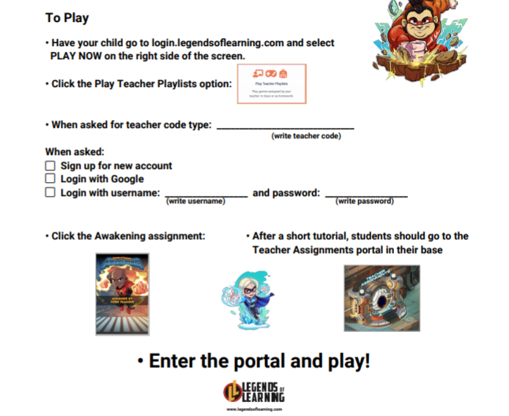

**Unfortunately, I do not have this information. Use the same Information you have been using throughout the year!**

**Mickus2**