Math 6 Escape Room: Day ONE – May 4, 2020

Day ONE
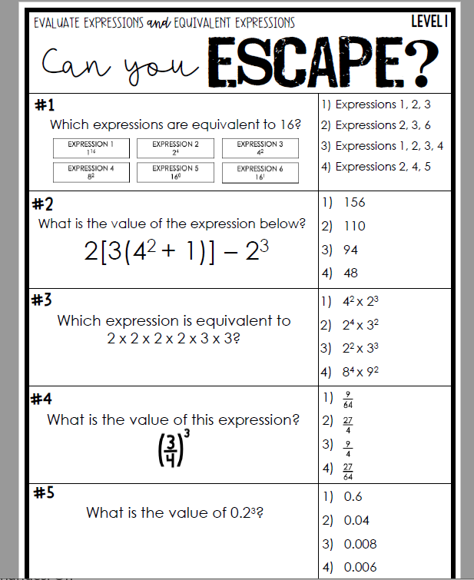
Escape Room Recording Sheet
Please record your answers and data, follow directions. Turn in this sheet only on Thursday, May 7, 2020

