UTP Statistics Quiz Assistance
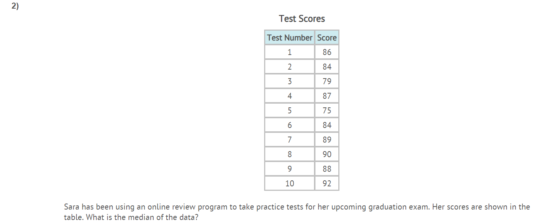
Step #1 put in order:
75,79,84,84,86,87,88,89,90,92
Eliminate to get to middle – Since there are two in the middle, add them and then divide by 2
86 + 87 = 173
173 ÷ 2 = 86.5

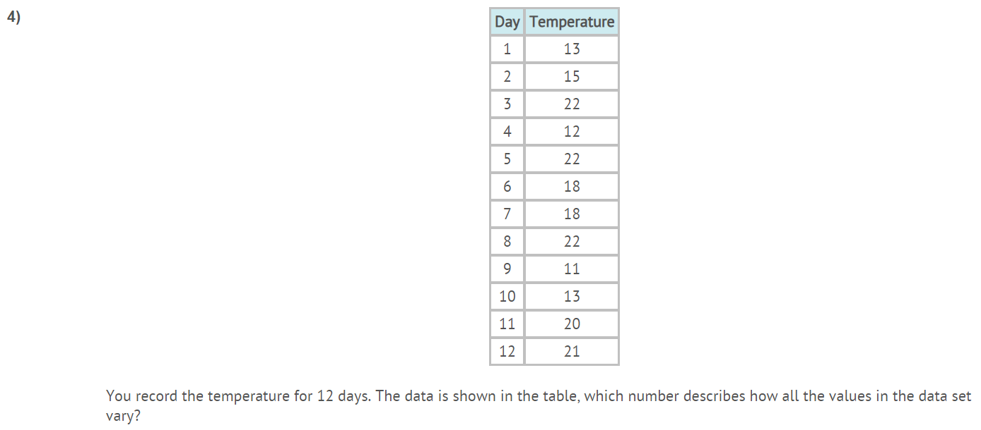
Variation is the range or the
difference in highest and lowest.
22 – 11 = 11
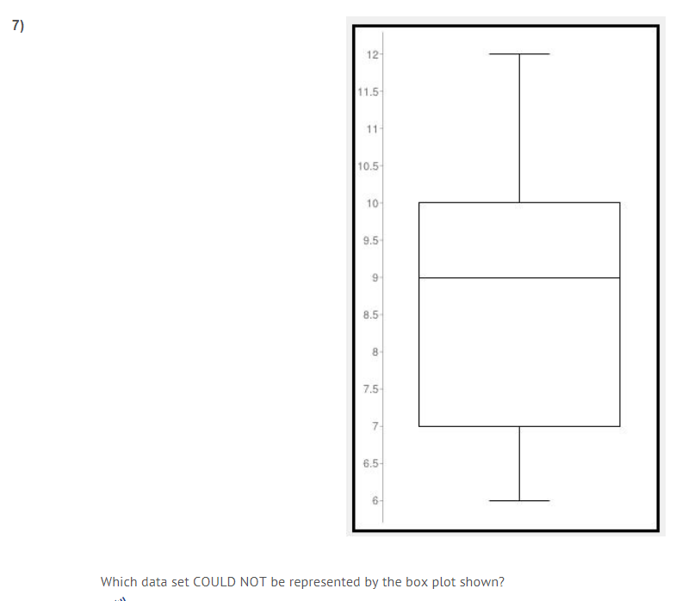
First order the data: 6,7,7,8,9,9,11,12,14
Lowest = 6
1st quartile = Middle # 6,7,7,8,9 = 7
Median = 9
3rd quartile = Middle # 9,11,12,14 = 11+ 12 = 23
23 ÷ 2 = 11.5
Highest = 14
Three of the answers have the same #’s only one does
not work based on above calculations

First put in order: You are looking for the mean of the upper quartile or from the median of the whole set to the highest number in the data set
( 3.9,4.1,4.2,4.3,4.3,4.4,4.4,4.4,4.4,4.5,4.5,4.6,4.6,4.8,4.9,5.0,5.1)
4.4 is median of data set or median of Q2
From 4.5 to 5.1 there are 8 numbers, 2 middle numbers are:
(4.6 + 4.8) = 9.4
2 2

