Stem and Leaf Plots with Decimals and Hundreds: Notes

The following examples provide some practice with stem-and-leaf plots.
Subjects in a psychological study were timed while completing a certain task. Complete a stem-and-leaf plot for the following list of times:
7.6, 8.1, 9.2, 6.8, 5.9, 6.2, 6.1, 5.8, 7.3, 8.1, 8.8, 7.4, 7.7, 8.2

The first thing I'll do is reorder this list. It isn't required, but it surely makes life easier. My ordered list is: We always do this first!
5.8, 5.9, 6.1, 6.2, 6.8, 7.3, 7.4, 7.6, 7.7, 8.1, 8.1, 8.2, 8.8, 9.2
These values have one decimal place. The stem-and-leaf plot only looks at the last digit (for the leaves) and all the digits before (for the stem). So I'll have to put a "key" or "legend" on this plot to show what I mean by the numbers in this plot. The ones digits will be the stem values, and the tenths will be the leaves.
Before After
Hundredth or all numbers to the right of the decimal
Decimal Decimal
Tens or all numbers to the left of decimal
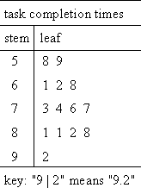
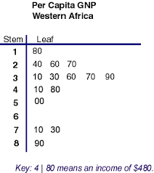
When working with numbers greater than 99, the hundreds will be
the Stem and the tens + the ones will be the leaves. Example:
180,240,260,270,290,410,450,500,710,730,890

