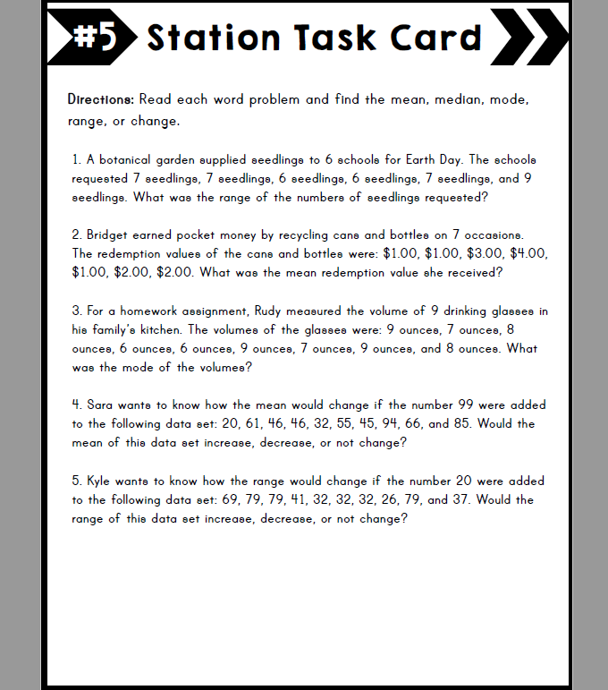

**WELCOME BACK FROM SPRING BREAK! Name: ____________________________**

**Read the directions along with each question carefully.**

**You may print this document or use a sheet of paper**