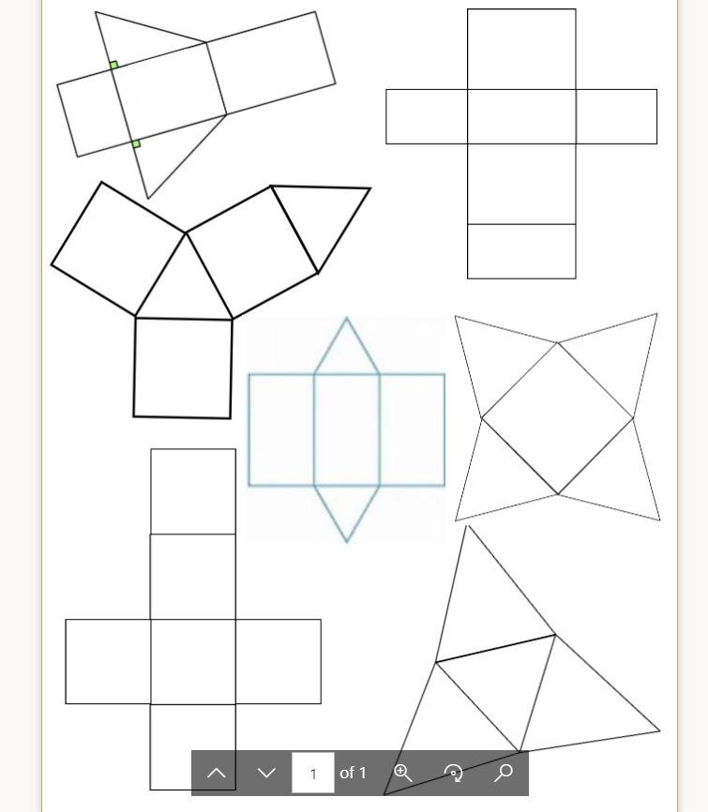

Cut

Cut out these 7 shapes and bring to class

On 3/3/3030. Cut out through this textbox.